3.22: Substituting for t in terms of d in the expression for 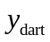 gives
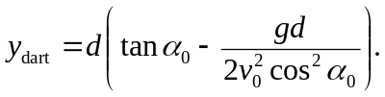

Using the given values for d and 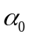 to express this as a function of ,
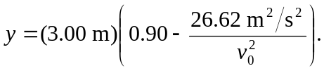
Then, a) 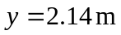, b) 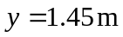, c) 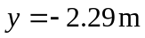. In the last case, the dart was fired with so slow a speed that it hit the ground before traveling the 3-meter horizontal distance.
d)
